Lab 1: Introduction to Google Kubernetes Engine (GKE)

SOFE 4790U

Distributed System Labs

September 18, 2022

Shwan Majeed, 100749077

Tiwaloluwa Ojo, 100700622

Manreet Kaur, 100766207

Mason Koitsan, 100749078

Shwan Majeed, 100749077

## Github Repo:

* Group work are divided into individual folders located in the master branch.
  + <https://github.com/tiwaojo/distributed-sys-labs>
  + If the link does not work, use the following for the videos:
    - [MySQL Deployment](https://drive.google.com/file/d/1vpdoGc_lBYmrqmqwu6BfldfY1V2RlAhU/view?usp=sharing)
    - [MongoDB Deployment](https://drive.google.com/file/d/1nC4j-gY8nkZmnet9fWbw74rWTQWjXsjL/view?usp=sharing)

### **Objective:**

In this lab, students will use Google Cloud Platform in order to get familiarized with Docker images and containers. This will be obtained by using kubernetes tools. Essentially, Docker is a space of software development tools, which include creating, sharing, and running individual containers. Additionally, Kubernetes is an open-source container platform used for managing, automating, and scaling containerized applications.

### **Discussion:**

Once the project was created, a compute zone was set and Kubernets Engine was enabled. Then a three-node cluster was created, and a pre made SQL image was used to deploy the application.

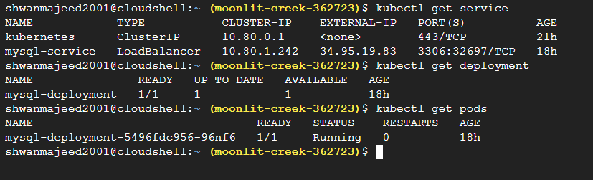

As seen in the image above, these are some kubernetes terminologies that were used within the lab. ‘Kubectl get deployment’ was used to check the status of the deployment after it was created. The ‘Kubectl get pods’ was used to check the status of the pods as well as get the pod name.

Next in the lab, MySQL logs were accessed and analyzed. To start, we need to specify the root password as it wasn’t given. To do so, we use the [ kubectl logs 2>&1 |grep GENERATED ] command to randomly generate a password. Once the password is generated, the password can then be changed for convenience using the [ ALTER USER 'root'@'localhost' IDENTIFIED BY ; ] command. After the password is fully created, the user can then log into the system. Once the sql user is created, a database was created in which data of people were inserted.

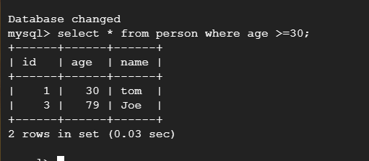

As seen in the image above, after the database was created, a command selecting people with the age of 30 and/or above were shown.

Also, the deployment was given an IP address. To start that, a load balancer service was created using the [kubectl expose deployment mysql-deployment --type=LoadBalancer --name=mysqlservice] command.

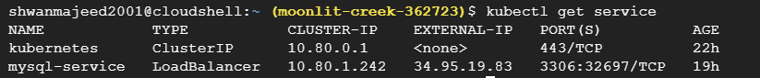

As seen in the image above, the external IP address is shown under the mysql-service. The [ kubectl get service] command is used in order to retrieve the IP address.

At the end of the lab, a more advanced deployment was looked at. A YAML file was created, which is another way to create an application. The YAML file was created within the editor and then was deployed to the GKE using the [kbectl apply -f mysql.yaml] command.

Docker is essentially used to create, run, and deploy applications in containers. A docker image is a file used to execute code in a docker container. There are many advantages and disadvantages with using Docker. Docker is known for having quick deployment, enabling data to be created and deleted in a short period of time. Docker is also very safe, in the sense of it;s security. Docker ensures that applications run on containers that are isolated from each other, which enables management flow. Although Docker has it’s advantages, it also has it’s disadvantages. Docker keeps data in a container, so if the container were to go down, it would need a backup to ensure the protection of the data. Additionally, docker has a list of missing features, as they are under progress and unable to be used.

A virtual machine is essentially a system that replicates a computer, where it requires a underlying operating system, and the hardware is virtualized. A couple advantages of using virtual machines include central location to manage all assets, expansion potentials, and use of thin clients. A couple of disadvantages include complexity, hardware keys, and the fact that hardware are often bundles together in one location.

* + 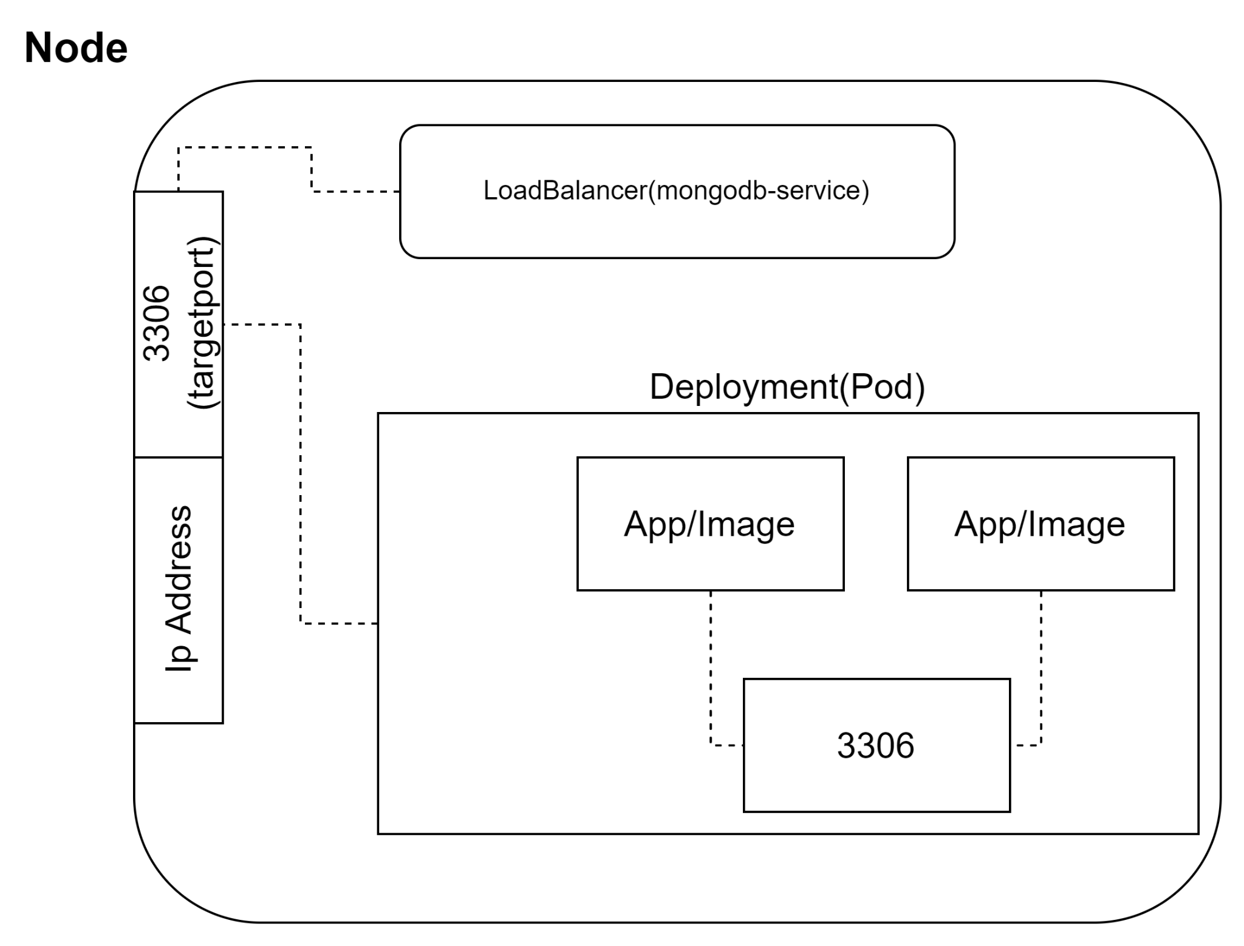
    - Mongodb yaml deployment script

apiVersion: v1

kind: Service

metadata:

name: mongodb-service

spec:

type: LoadBalancer

ports:

- port: 3306

selector:

app: mongodb

---

apiVersion: apps/v1

kind: Deployment

metadata:

name: mongodb-deployment

spec:

replicas: 1

selector:

matchLabels:

app: mongodb

template:

metadata:

labels:

app: mongodb

spec:

containers:

- image: bitnami/mongodb:latest

name: mongodb

env:

- name: MONGODB_SHELL_CREATE_DATABASE_USERNAME

value: user

- name: MONGODB_ROOT_USER

value: user

- name: MONGODB_ROOT_PASSWORD

value: sofe4790u

- name: MONGODB_SHELL_CREATE_DATABASE_NAME

value: myDB

ports:

- containerPort: 3306

name: mongodb

* + - Cmd to create a collection in mongodb and populate it with entries:

db.createCollection("person");

db.person.insertMany([

{

name:"john",

age: 30},

{

name:"tom",

age: 29},

{

name:"adam",

age: 79},]

)

* + Design: No kubernetes tool outside of the lab was used.